Anchor Bay Middle School
Retake/Test Correction Policy
Subject – 6th Grade Language Arts

Who is eligible to make test corrections?
All students are able to make test corrections to earn a half point back for each point lost on the original assessment.

When will test corrections be done?
- Test corrections will take place before or after school within the Testing Center.
- The test corrections must be done in the Testing Center within one week of the assessment being returned to the student.

What must be done prior to arriving at the Testing Center to make test corrections?
- There must be a parent signature on the original assessment.
- Students must make advanced arrangements with their teacher in order to be allowed to complete test corrections.

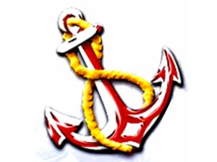

Anchor Bay Middle School
Test Correction Form

Student Name: ____________________________________ Grade: _____ Hour: ____
Teacher: ______________________ Original Score: _________

Test correction is scheduled for: ___6th Grade Lang. Arts____
Location and Time ________________________________

Please attach the original test with parent signature to this form before arriving to the Testing Center to take make your test corrections.

Test correction form will be given to students at the testing center. All corrections must be made on this form in order to earn credit.

Students must bring all materials necessary (study guide, book, INB, Etc.) to the Testing Center on the arranged day.

